Client / Owner: | Ridley College
Contractor: | Roberston Restoration
Project Materials observed onsite: |  | Titanium UDL 30 Synthetic Roofing Underlayment by Owens Corning, Lastobond Shield HT by Soprema, Pre-punched, Unfading Black, 7mm thick, 16x12, 6x10, 6x9, and 6x8 slates from North Country Slate

Pretium was on site to review the progression of work. Only items observed by the reviewer and reported herein have been reviewed. Other conditions may be present that were not apparent to the reviewer at the time of the visit. The following was observed / discussed:
OBSERVATIONS / COMMENTS
- General
  - Project Status: 50% complete
  - Original Estimated Project Completion Date: August 23, 2024 (weather permitting)
  - Projected Completion Date: Project will not be completed by Aug. 23. Roberston is focusing on finishing south and east faces by Aug. 23 deadline to accommodate students returning to campus.

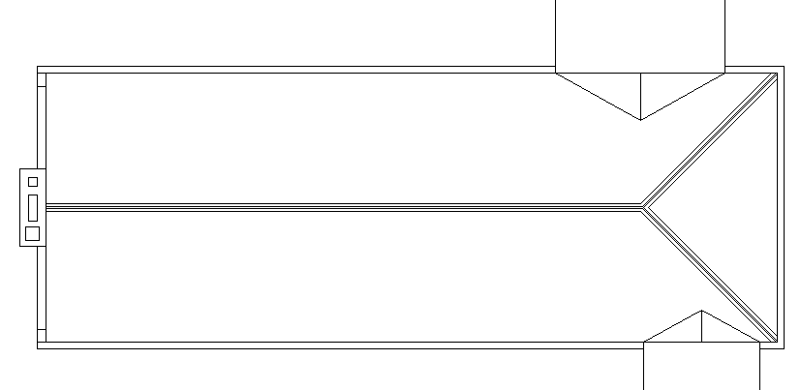
KEY PLAN
NOT IN CONTRACT
SCAFFOLDING IN PLACE
ACTIVE WORK AREA AT TIME OF VISIT
COMPLETE TO NEW UNDERLAYMENT
COMPLETE TO NEW SLATE



- Site / Staging Area
  - No changes in the staging area since Pretium’s previous visit were observed.
- Slate Roof
  - Foreman onsite advised they anticipate slate in field of east face will be complete next week (Aug. 19-23). Robertson is aware of the Aug. 23 completion date and is striving to complete the east and south faces and demobilize from these locations by then.
- Overview of completed slate in the field of the south face. | 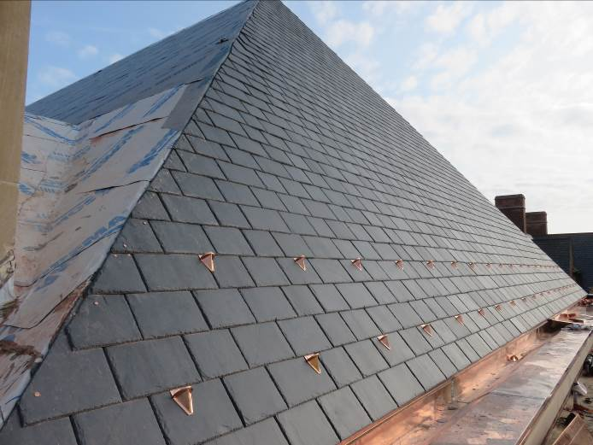
- New slates were removed to accommodate installation of new snow guards on south face. Slates were reinstated using hooks which is standard practice when making slate repairs. | 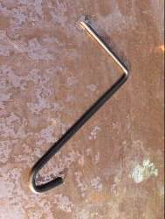  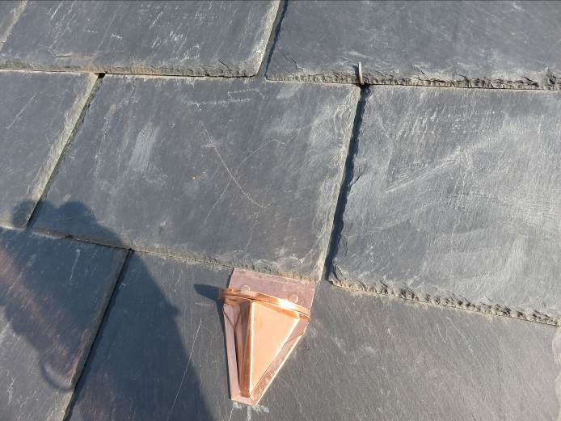
- New copper gutter is complete on the south face. | 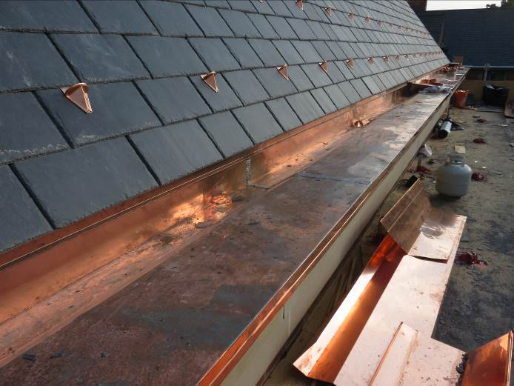
- New soldered expansion joint at mid-point of copper gutter on the south face. | 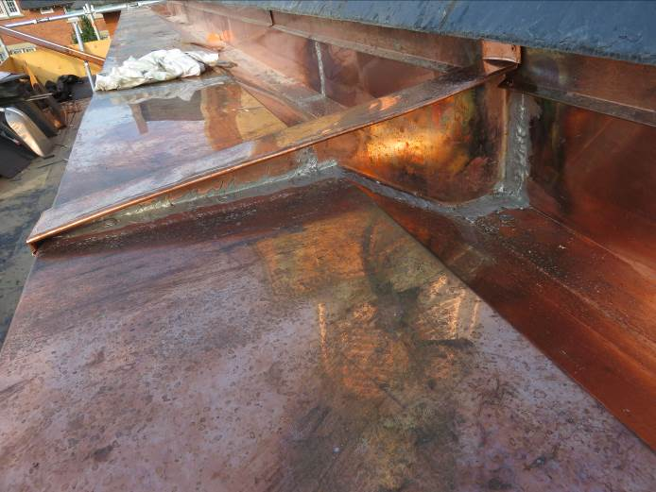
- New copper flashings are complete on the south face. | 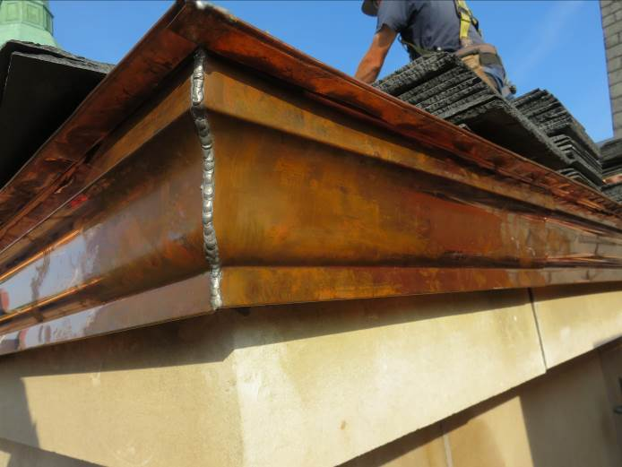
- Installation of new slate at the east face was in progress at time of visit. | 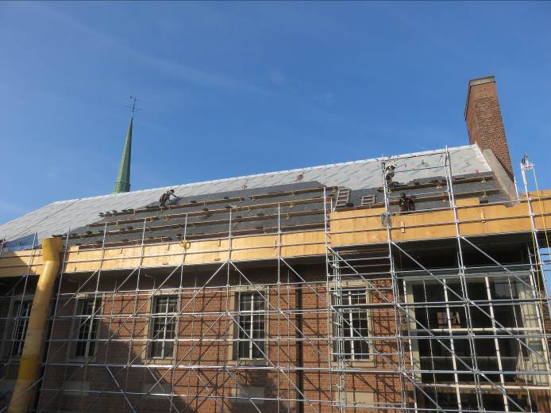
- Installation of new slate at the south end of the east face was in progress at time of visit. New snow guards have been installed concurrently with the new slate in this location. | 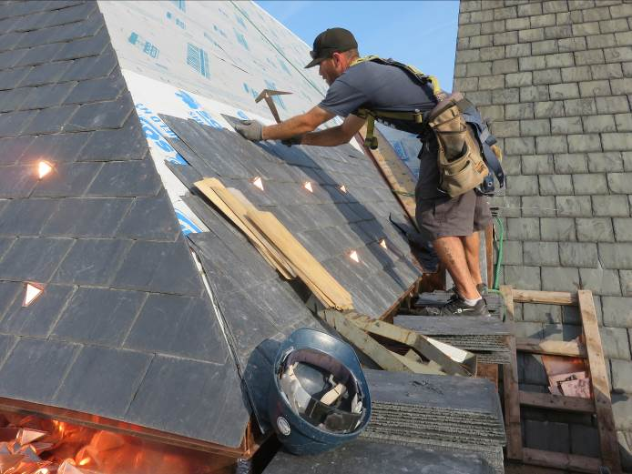
- New copper step flashings are being installed at the northern parapet detail as specified. | 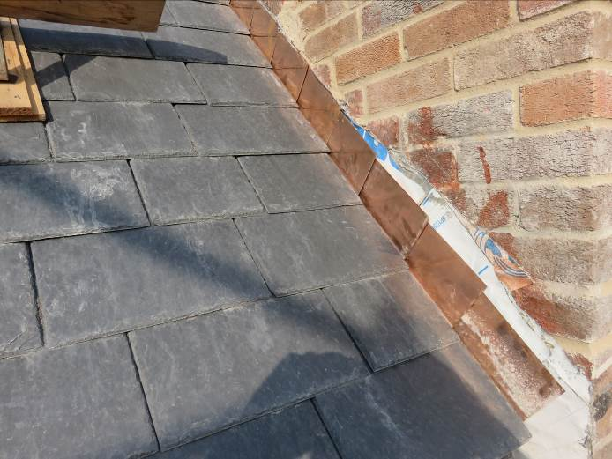
- Completed brick repairs at north end of east face. | 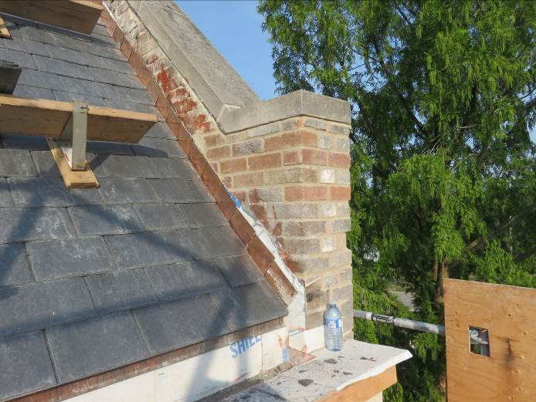

This report was issued to all parties on November 7, 2026.
Trade foreman was verbally notified of report contents. This report pertains to work specifically requested and comments only on operations and items that were visible or being undertaken at the time of our inspection.
Report by: | Dave Neal. H.Dipl.T., RRO

